**CHANGING PORT OF GAMEOFLIFE**

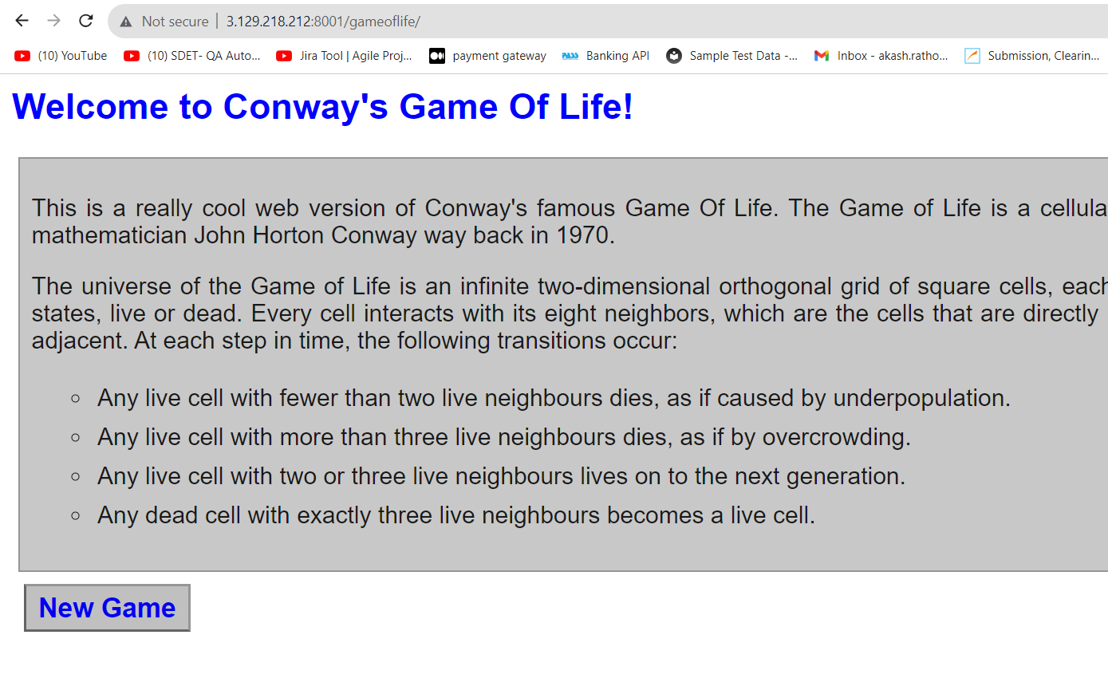

* Launch an instance
* Connect to instance
* Install java 8
* Install git & maven
* Clone repository & navigate into it
* mvn clean install (where pom.xml file is present)
* war file is created in target directory (game-of-life/gameoflife-web/target/gameoflife.war)
* go to mnt and create directory servers
* install tomcat 9 and unzip it
* give 777 permissions to tomcat directory
* go to webapps and copy (get) war file to current location
* go to conf directory in tomcat and open server.xml
* change connector port 8080 to 8001 and save
* change the port in security group, same as entered in server.xml
* go to bin and start the server
* check ip:8001/gameoflife